Design Document

Orchestra

10/31/2024

Version 1

Matthew Ingallinera, Gabe Roberts, Albert Lusk

1. Project Overview:

The primary goal of our application is to promote collaboration between UNCG students, specifically in regards to music production. Our application will allow students to showcase and sell music they produce. And allow others on campus to contact them for the purpose of collaborations. There are a multitude of student run projects and clubs that incorporate music. Such as: Carmichael Studios, members of the UNCG game dev club, and other music producers on campus that are interested in collaborations.

1. Use-Case Model

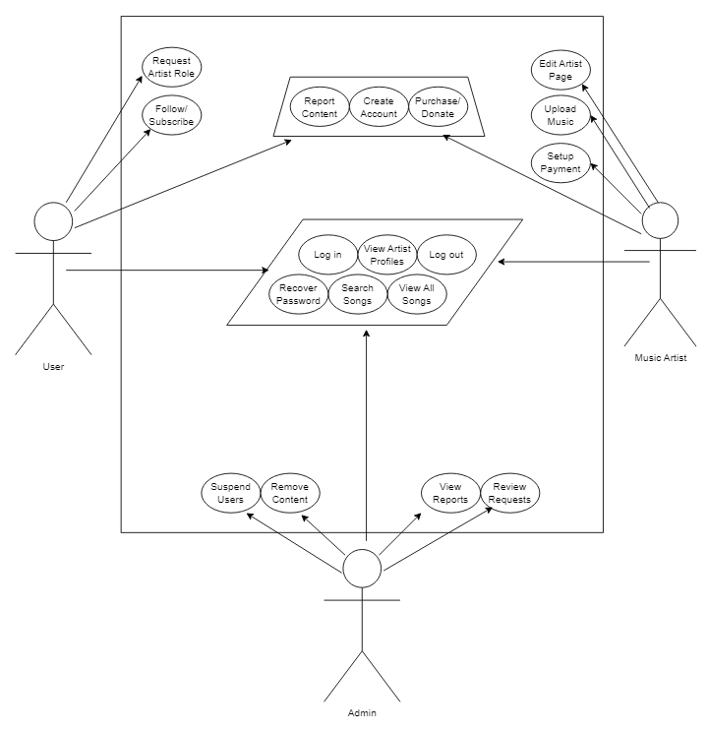

1. State Machine Diagrams:

User: Matthew Ingallinera

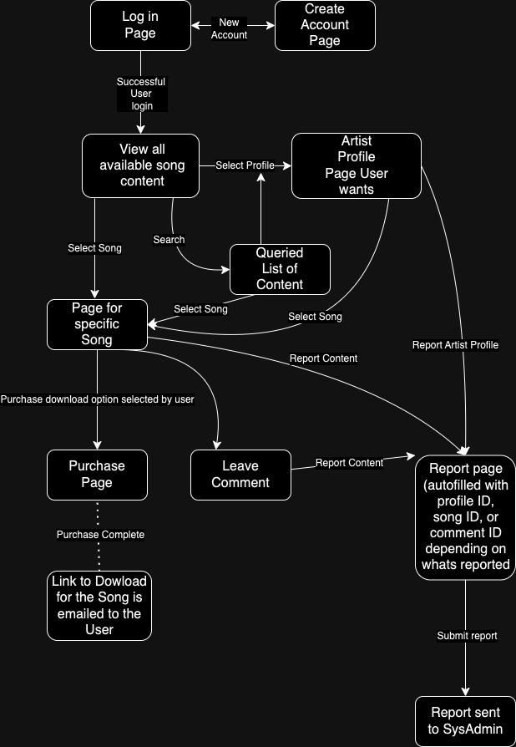

Artist: Gabe Roberts

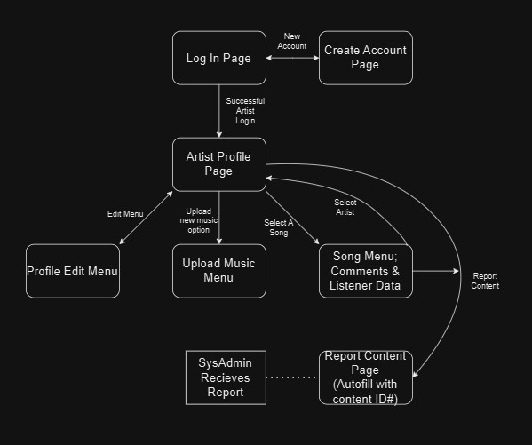

Admin: Albert Lusk

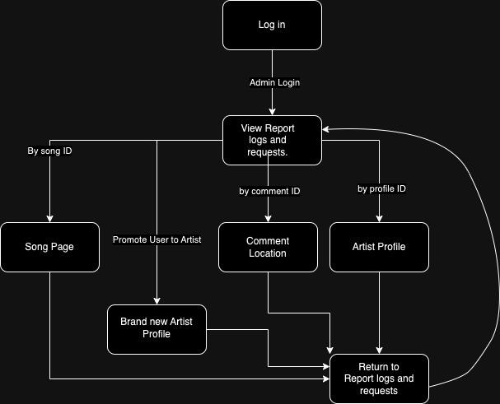

1. Database Schema:

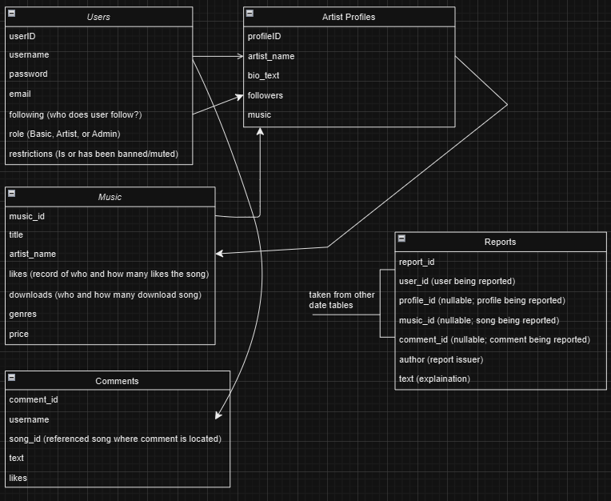

1. Software Architecture - MVC

